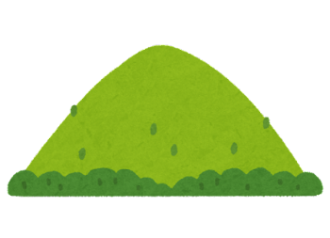The snow [glows](https://www.definitions.net/definition/glows) white on the [mountain](https://www.definitions.net/definition/mountain) tonight

Not a [footprint](https://www.definitions.net/definition/footprint) to be seen

A [kingdom](https://www.definitions.net/definition/kingdom) of isolation

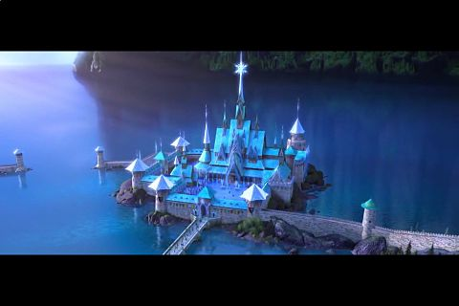And it [looks](https://www.definitions.net/definition/looks) like I'm the queen

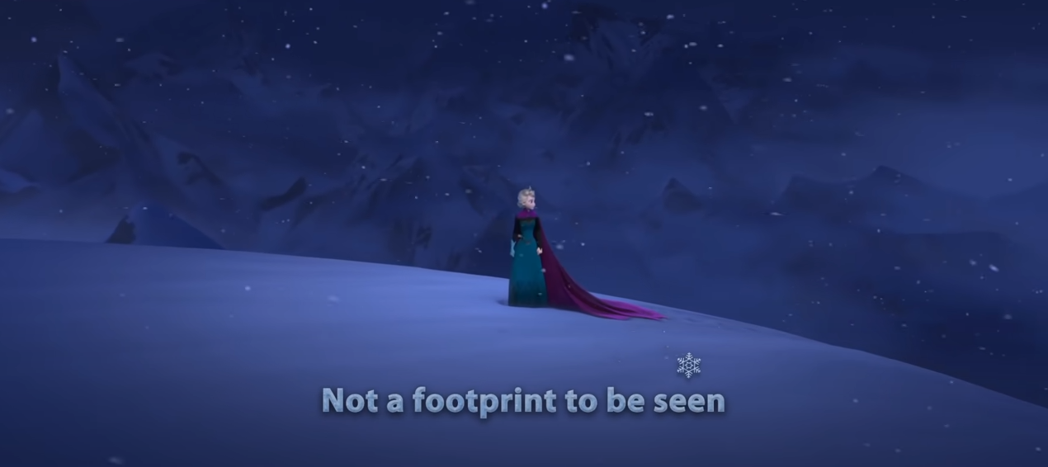

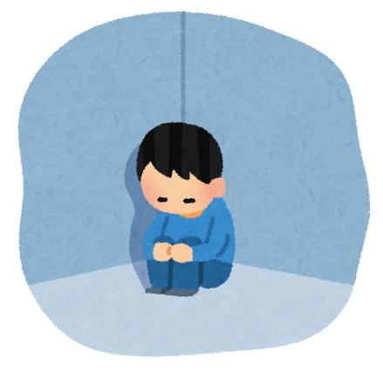

The wind is [howling](https://www.definitions.net/definition/howling) like this [swirling](https://www.definitions.net/definition/swirling) storm inside

Couldn't keep it in, [heaven](https://www.definitions.net/definition/heaven) knows I've tried

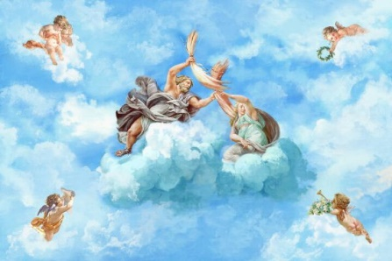

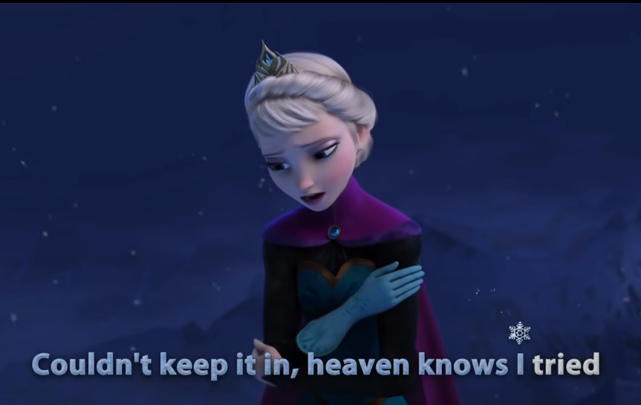

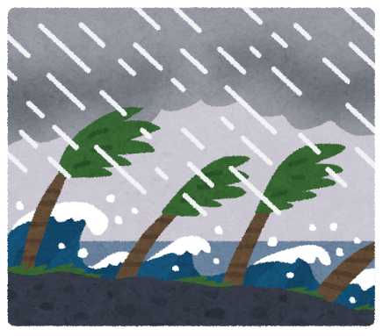



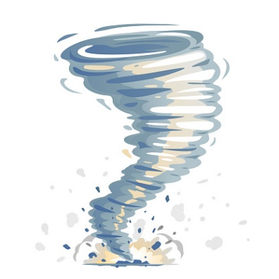

Don't let them in, don't let them see

Be the good girl you [always](https://www.definitions.net/definition/always) have to be

Conceal, don't feel, don't let them know

Well, now they know

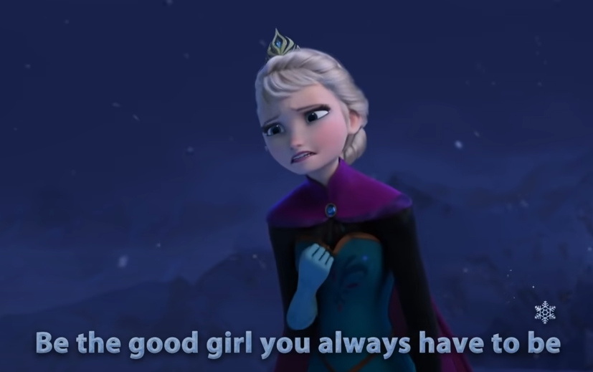

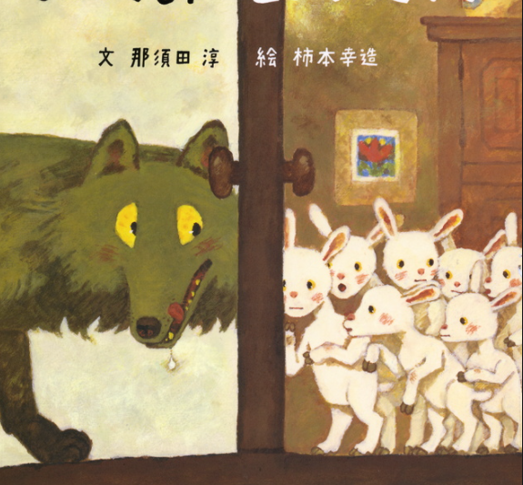

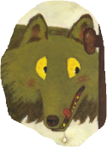

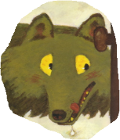

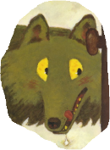

Let it go, let it go

Can't hold it back anymore

Let it go, let it go

Turn away and slam the door

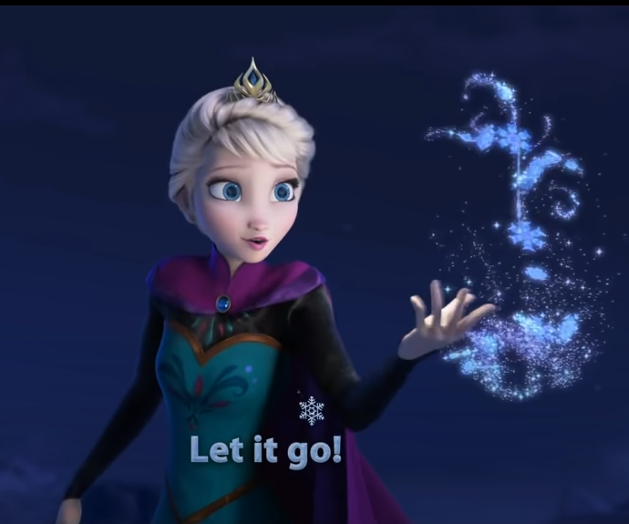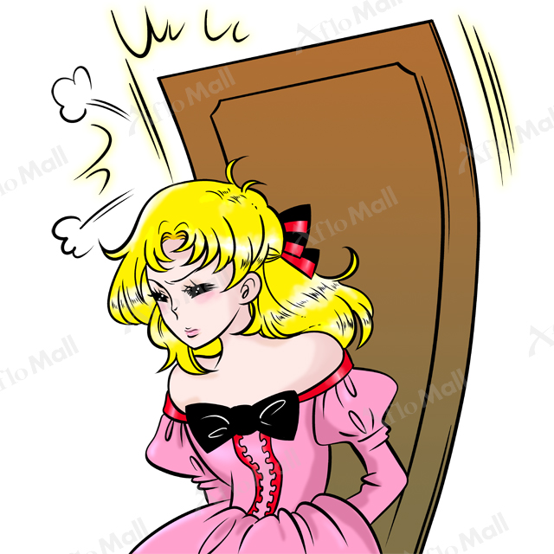

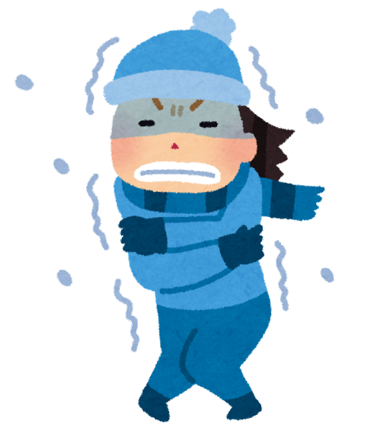I don't care what they're [going](https://www.definitions.net/definition/going) to say

Let the [storm](https://www.definitions.net/definition/storm) rage on

The cold [never](https://www.definitions.net/definition/never) bothered me anyway

